CGS Buzzer System – Usage Instructions

# 1: The Buzzers

## 1.1 Assembling a Buzzer

### Parts Required

#### Procurable Parts

Below is a list of parts that will need to be purchased for each buzzer required.

Please note: it is possible that the Computer Science department will have spare edge connector breakout boards, battery holders, and micro:bits that can be used.

|  |  |  |
| --- | --- | --- |
| **Part** | **Cost per Unit** | **Purchase Link** |
| 12mm Momentary Push Button | Approx. £0.29 | [Amazon](https://www.amazon.co.uk/Gebildet-Momentary-Lockless-Trumpet-Doorbell/dp/B07XRBDBXT/ref=sr_1_5?crid=3EP9C6XYGHW7N&keywords=Click%2Bto%2Bopen%2Bexpanded%2Bview%2B18Pcs%2B12mm%2BWaterproof%2BMomentary%2BPush%2BButton%2BSwitch&qid=1702401111&s=industrial&sprefix=click%2Bto%2Bopen%2Bexpanded%2Bview%2B18pcs%2B12mm%2Bwaterproof%2Bmomentary%2Bpush%2Bbutton%2Bswitch%2Cindustrial%2C145&sr=1-5&th=1) |
| WS2812 (‘NeoPixel’) 5050 RGB Ring (7 LEDs) | Approx. £1.51 | [Amazon](https://www.amazon.co.uk/dp/B0CF5XMSFC?psc=1&ref=ppx_yo2ov_dt_b_product_details) |
| Edge Connector Breakout Board | £5.10 | [The PiHut](https://thepihut.com/products/edge-connector-breakout-board-for-bbc-micro-bit-pre-built) |
| Dual AAA Open Battery Holder with JST PH Connector | £1.50 | [The PiHut](https://thepihut.com/products/2-x-aaa-open-battery-holder-with-jst-ph-connector) |
| BBC micro:bit V2.2 | £16.10 | [The PiHut](https://thepihut.com/products/micro-bit-v2) |

#### 3D Printable Parts

|  |  |  |  |
| --- | --- | --- | --- |
| **Part** | **Quantity** | **Recommended Filament** | **File Path** |
| Stand | 4 | Black 1.75mm PLA | ‘Design Files’/Stand.stl |
| Stand Brace | 1 | Black 1.75mm PLA | ‘Design Files’/Brace.stl |
| Plate | 1 | Black 1.75mm PLA | ‘Design Files’/Plate.stl |
| Breakout Holder (one LEFT, one RIGHT) | 2 | Black 1.75mm PLA | ‘Design Files’/BreakoutHolder-[*LEFT/RIGHT*].stl |
| Light Diffuser | 1 | Transparent 1.75mm PLA | ‘Design Files’/Diffuser.stl |

#### Tools Required

When assembling the buzzers, the following tools will be required:

* 3D Printer (to print the parts)
* Soldering Iron & accompanying equipment (to solder wires to the components)
* Heat Gun (to add heat shrink to protect certain solder joints)
* Superglue or Hot Glue Gun (to attach components)

### Initial Assembly

PICTURES REQUIRED

The tutorial below will only have to be followed once – when the buzzer is first assembled.

1. Firstly, purchase and 3D print the required parts, and gather the required tools.
2. Slot the 4 stands into the cutouts in the stand brace. Use either superglue or hot glue to hold these together.
3. Use hot glue to stick the battery holder onto the upwards-facing side of the stand brace (making sure to poke the cable through one of the holes).

### Wiring Diagram

## 1.2 Flashing the Firmware

# 2: The Controller App

The Controller App is critical in hosting an event. It communicates with all the buzzers and presents an easy-to-use interface to the host, allowing them to design and control the event.

IMPORTANT: The Controller App will not load unless the controller micro:bit (see above) is connected to the hosting device (be it desktop or laptop) via USB. Please ensure it is connected before trying to follow the guide below.

## 2.1 The Interface

The Controller App uses a tabbed interface. Most of the functions required to setup and run an event will be found on different pages.

Below follows a brief overview of all the tabs (and their functions) in the app.

### Hosting Tab

The Hosting tab is the primary tab used to host an event.

It displays the current question (including the round, answers, notes, and aid control); the ‘**Buzzer Control Frame**’ (to allow the host to open, close, and lock the buzzers); and the ‘**Load Set**’ button (which is used to open a new question set).

The only hosting-related functions that cannot be accessed from within the Hosting tab are the live scoreboard, and soundboard.

**Question Set Frame** – displays the name of the current question set, and the current round. Also contains the button to load a question set.

Tab switching buttons.

Displays the current question, answer, and notes.

**Question Aid Control** – contains the controls for media (video, audio, or images) embed in questions.

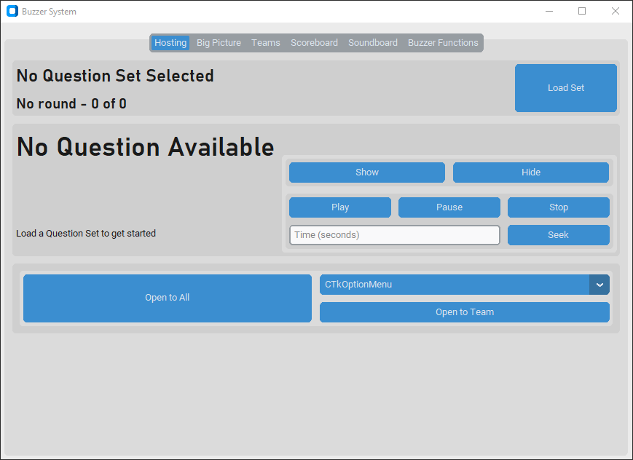

**Buzzer Control Frame** – contains options to open, close or lock buzzers. The available buttons will change depending on the state of the buzzers (full guide in 2.4).

### Big Picture Configuration Tab

The **Big Picture Display** is the primary method of displaying the information about the game to the audience. It can be used to display a wide range of information (such as the current question, round, or live scoreboard).

This tab gives the host control over the Big Picture Display. It can be used to switch the page being displayed to the audience, as well as opening the display and setting it to be full screen.

This tab can also be used to set a title for the event, which is displayed to the audience in the ‘**Title**’ page.

For a full guide on using the Big Picture Display see **Section 2.3**.

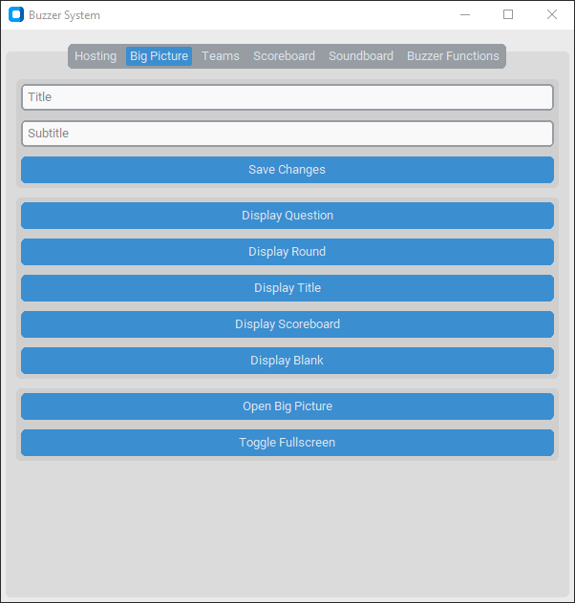

Set the title to display on the Big Picture (the button must be pressed for changes to take effect).

These buttons can be used to open and full screen the Big Picture display.

These buttons can be used to change the page that the Big Picture is displaying.

### Team Setup Tab

The Team Setup tab is the primary tab used during the event setup process. This tab is used to setup teams, and their colour palettes, as well as assigning buzzers their aliases and linking them to the correct team.

The Team Setup tab also provides the option to ‘**Identify**’ an individual buzzer. This will highlight it from the rest of the set. This function could be useful when introducing contestants, or to identify which alias to assign to which buzzer during the setup process. To remove the highlight from the buzzer, it is important to press the ‘**Stop Identify**’ button.

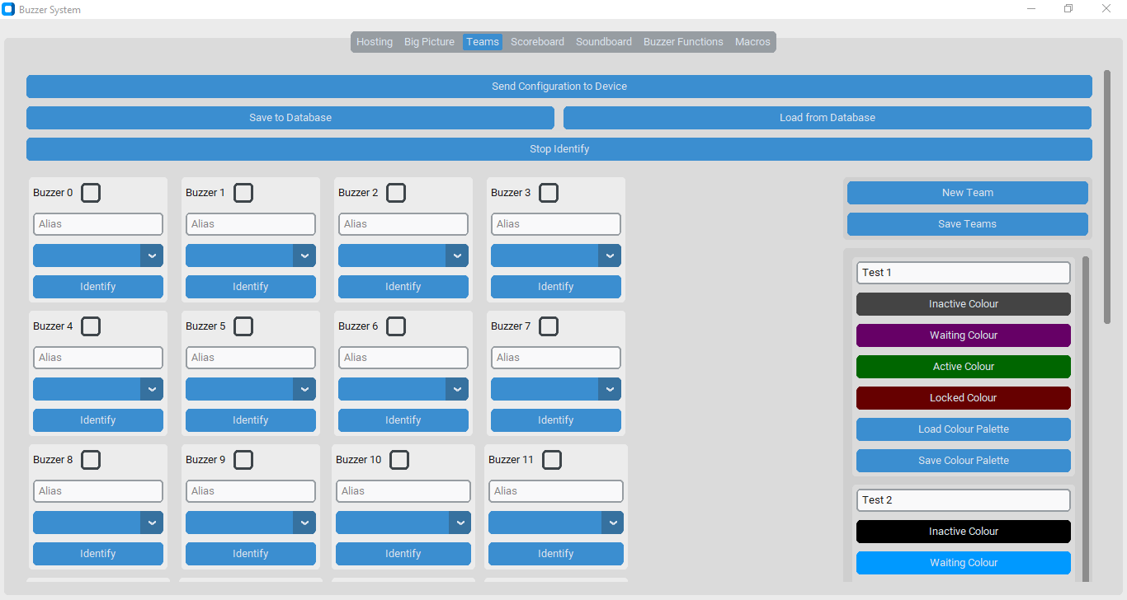

Setup individual buzzers.

Create teams and edit their names and colour palettes.

Stop identifying an individual buzzer.

Buttons to save and load existing configurations from the database.

Send the displayed team configuration to the controller micro:bit, which starts the system. No changes will be saved unless this button is pressed.

### Scoreboard Tab

The Scoreboard tab provides the host with a live view of the scores for each team.

Also, the host can manually adjust the scores by applying penalties or bonuses to a team as they wish.

Manually add or remove points from each team.

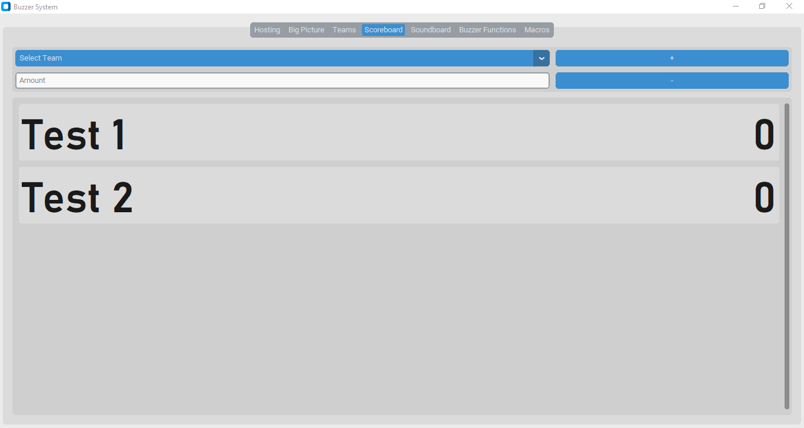

View the points that each team has, ordered from highest to lowest.

### Soundboard Tab

The Soundboard tab simply gives the host to option to play sound effects to the audience. There are 8 sound effects available by default.

To stop a sound effect once it has started playing, press the ‘**Stop All Sounds**’ button.

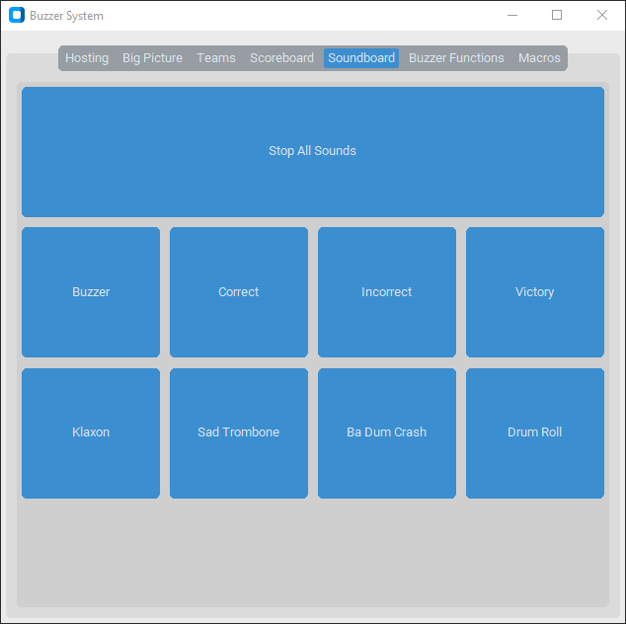

Press a button to play the named sound effect.

### Buzzer Functions Tab

The Buzzer Functions tab contains some of the key functions for resetting and fine-tuning the operation of the buzzers during an event.

It only contains 5 buttons, but it is important to understand the effects of each of them.

Resend Configuration to Device – this instructs the controller to resend the configuration it currently has stored to each buzzer. This is most likely to be used if a new buzzer is added midway through the game (as the ‘**Send Configuration to Device**’ in the Team Setup tab will reset the scores to 0, but this will not).

Lights On / Off– tell the buzzers to turn on or off their internal LEDs.

Update Lights– if a buzzer were to freeze and stop responding, this can be used to force it to update its state. If this fails to fix the problem, use ‘**Resend Configuration to Device**’ above.

### Macros Tab

PASS

HERE BE MACROS

## 2.2 The Big Picture

The **Big Picture Display** is the audience’s primary view of an event. It can display titles, rounds, questions, scoreboards, and more.

The Big Picture Display is controlled through the **Big Picture Configuration Tab**.

Using the Big Picture Display is not compulsory but is recommended. If the Big Picture Display is not required, skip past the following tutorials.

### Display Views

Question – display the current question, and any associated question aids.

Round – display the current round number and name.

Title – display the user-specified title and subtitle for the event.

Scoreboard – display the current scores by team, sorted from 1st to last.

Blank – display nothing, just a black screen.

**Whenever a player buzzes in, their name and team will display at the bottom of the Big Picture Display in their team colours.**

### Setting Up the Display

1. To open the display, click ‘**Open Big Picture**’.
2. Drag the window to the appropriate monitor or display.
3. Click ‘**Toggle Fullscreen**’ to turn the window full screen.
4. Set the title for your event:
   1. Type the desired title value in the top text-entry box.
   2. Type the desired subtitle value in the bottom text-entry box.
   3. Press the ‘**Save Changes**’ button.
   4. If not using a Question Set, press the ‘**Display Title**’ button.
5. If using a Question Set, load it now (using the tutorial found in **Section 2.3.2**).

### Using the Display

When hosting an event, there are automatic triggers which will change the display of the Big Picture Display. These are listed below:

When a Question Set is loaded – display **Title**.

When the title is updated – display **Title**.

When a round ends – display **Round**.

When the question advances – display **Question**.

When the question ends – display nothing (**Blank**).

When the game ends (or the Question Set runs out) – display nothing (**Blank**).

However, the host can also manually change the view the Big Picture Display is showing by using the ‘**Show [*view*]**’ buttons in the **Big Picture Configuration Tab**.

## 2.3 Setting Up an Event

It is advisable to complete the following setup procedure before the audience arrives at an event.

1. The individual buzzers must be setup. Follow the tutorials in **Section 1.2** before moving on with the setup process.
2. If an event calls for the use of the **Big Picture Display**, use **Section 2.2** to initialise this now.

If the above two steps have been completed, it is now safe to setup the teams and Question Set.

### Setting up Teams

Navigate to the ‘**Team Setup**’ tab.

#### Using a Pre-Created Team Configuration

1. Press the ‘**Load from Database**’ button.
2. Select the name of the configuration from the pop-up.
3. Press the ‘**Submit**’ button in the pop-up.
4. Load or set the colour palettes for each team.
5. Make any required changes to the configuration (aliases, team names, etc.).
6. Press ‘**Send Configuration to Device**’.

*The buzzers should each light up with their respective inactive colour.*

#### Creating a New Team Configuration

1. Add the required teams:
   1. Press the ‘**New Team**’ button.

*A new team entry should appear at the end of the list.*

* 1. Set the name of the new team in the ‘**Name**’ text entry box.
  2. Either load or set the correct colour palette for the team.
  3. Repeat this process for each team.
  4. Press the ‘**Save Teams**’ button.

1. Set the individual data for each buzzer:
   1. Find the box labelled ‘**Buzzer [*ID*]**’, where ID is the ID of the buzzer to edit (from 0 to 24 inclusive).
   2. Tick the checkbox as required to indicate if the buzzer is active.
   3. Set the alias of the buzzer (the player’s name) using the text entry box labelled ‘**Alias**’.
   4. Use the dropdown to select which team the buzzer should be assigned to.
   5. Repeat this process for each buzzer to be used or edited.
2. Press ‘**Send Configuration to Device**’ to lock it in.

If the team configuration is likely to be used again, store it in the database, press the ‘**Save to Database**’ button and enter the name to save it as (WARNING: if there are any name conflicts, the existing configuration will be automatically overwritten). This will improve the efficiency of the setup procedure, as now the configuration can be easily reused multiple times, without completely reconfiguring it each time.

#### Setting Colour Palettes

Each team has a colour palette of 4 colours, which are sent to each buzzer and appear on the LED array. More information on this can be found in **Section 1.1**.

Inactive– the colour displayed when the buzzer is not active, locked or waiting for press.

Waiting– the colour displayed when the buzzer is waiting to be pressed.

Active– the colour displayed when the buzzer was pressed before anyone else, and the player is now being asked for their answer.

Locked– the colour displayed when the player answered a question wrong, so is now locked out of buzzing for the rest of the current question.

A colour palette can be loaded from the database, by pressing ‘**Load Colour Palette**’ in the desired team’s entry and selecting the name from the list.

Or colour palettes can be manually created by pressing any of the colour buttons (‘**Inactive Colour**’, ‘**Waiting Colour**’, ‘**Active Colour**’, ‘**Locked Colour**’) for the target team, and picking a colour from the selector prompt. Once created, a colour palette can be saved to the database by pressing the ‘**Save Colour Palette**’ button (WARNING: as with team configurations, if a name conflict occurs, the existing colour palette will be automatically overwritten).

### Loading a Question Set

1. Switch to ‘**Hosting**’ tab.
2. Press the ‘**Load Set**’ button in the top-right hand corner of the screen.
3. Select the name of the Question Set to load from the dropdown in the prompt that appears.
4. Press ‘**Submit**’ on the pop-up prompt.

*The Question Set should now load, and the* ***Question Display Frame*** *will display the first question.*

*If the* ***Big Picture Display*** *is opened, it will switch to the* ***Title*** *view.*

## 2.4 Hosting an Event

Before hosting an event, ensure that the setup procedure (in **Section 2.3**) has been properly followed.

### Controlling the Buzzers

Throughout a question, the **Buzzer Control Frame** will change to display buttons that are best appropriate to the current state of the buzzers:

#### Advance Question

This frame simply has one button

#### Advance Round

#### Buzzers Closed

#### Buzzers Open

#### Buzz Received

### Dealing with Questions

### Using the Scoreboard

### Something about Big Picture?

# 3: The Set Creator App

# 4: Technical Details